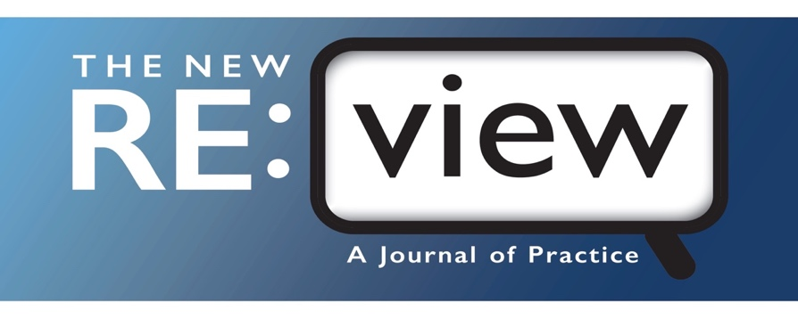

# Media Consent and Release Form

*The New RE:view–A Journal of Practice* (TNR) is a peer-reviewed professional journal that focuses on practioner-oriented articles related to the education and rehabilitation of people who are visually impaired or blind. TNR publishes applied research findings and proven strategies and approaches that can strengthen our professional community of practice. TNR is intended for professionals in this field, people with visual impairments, their families, and anyone who works with them.

Photographs of the person or persons named below may contain personally identifiable information in articles published in *The New RE:view.* By signing this consent form, I understand and acknowledge that:

* *The New RE:view–A Journal of Practice* has my permission to use the photographed likeness of the participant named below in printed and digital publications of the journal.
* No monetary consideration shall be paid to any party for the use of photo(s) submitted by author(s) of the published article.
* This permission is given without coercion or duress and is binding upon my heirs and/or future legal representatives.
* This permission remains in effect until such time as I notify *The New RE:view* in writing that I wish to revoke it for future projects.
* This permission waives any copyright interest or ownership rights that I might have for such photographs.

Please complete a separate form for each individual involved in the photos to be submitted.

Participant First and Last Name:

I, the person named above, am the individual featured in the photo(s).

I am the Parent/Guardian/Other Person with Legal Authority (Power of Attorney, Voluntary Adult Caregiver, or Agent) of the person listed above. I give permission to *The New RE:view* for publication of photos as detailed in this release.

Signature: Date Signed: