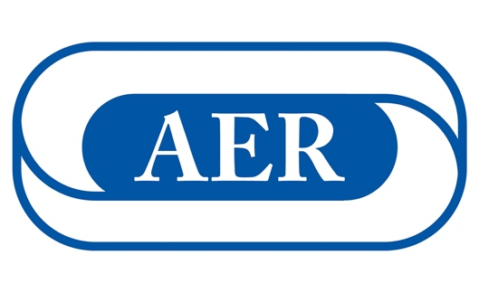

# **Learn What Being an AER Member Can Mean for You**

**AER**—the Association for Education and Rehabilitation of the Blind and Visually Impaired—is a membership organization dedicated to professionals who provide service to persons with vision loss. AER promotes and supports its members by advocating for evidence-based practices, high-quality standards, value-added resources, and giving voice to issues of critical importance. AER also provides professional development through conferences, virtual offerings, and publications designed to strengthen the knowledge, skills, and abilities of professionals within the field.

By becoming a member of AER, you join a community of excellence. No matter your role or the number of years in the field, membership in AER places you among a group of dedicated, caring professionals who support each other. AER is a member-centered organization, and, for that reason, we are constantly evolving, growing, and listening.

The **Mission of AER** is to serve and empower professionals to deliver standards-based practices that lead to improved educational and rehabilitative outcomes for individuals with visual impairment and blindness.

The **Vision of AER** is to be a dynamic and thriving professional membership community with innovative practices and standards that result in responsiveness, recognized leadership, and improved outcomes for individuals who are blind and visually impaired.

Membership in AER is significant; it’s the one place where like-minded professionals in this field come together to make sure we all have what we need to succeed!

To learn more about AER and how you can become a member, visit [www.aerbvi.org](http://www.aerbvi.org).